Lesson 20 The Beast within the beauty

When we get saved, we are to put on the beauty of holiness but there is still a beast that lies within.
Sometimes the beast will arise, and you have to put yourself underneath the authority of the Holy Spirit. Sometimes you have to remind yourself that your mind is constantly being renewed by the Holy Spirit

The Struggle
- The inward struggle is a daily struggle that has to be tamed every day
- The word Beast= One who acting in an unworthy manner of who they are
- The word Beauty= One who acts worthy of who she is; one who acts in crazy
- Even though your saved and sanctified there are times where you will act outside of who you are.
- The beast will rise up it is a daily struggle:
“Remember what comes up doesn’t have to come out”

- There are 2 dogs within everyone the one you feed is the one who will be in control. Sometimes we feed the wrong dog.
- As long as you allow your emotions to rule the enemy doesn’t have to bother you, because he already has you.
- When you make the decision to follow Christ the enemy gets mad and tries to cause you to stumble.
- The enemy wants your beast to arise but that is why the struggle is real and you must renew your mind daily and focus on that which is of God.

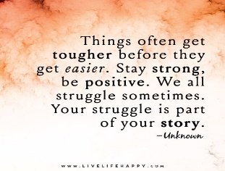
The Beauty of Holiness (Holiness is Beautiful)
- Worship the Lord in the beauty of holiness by living a life that reflects the beauty of God.
- God never stops loving you; God never stops forgiving you!
- You are God’s daughter and the apple of God’s eye; he loves you with an everlasting love!
- Thank God that everything for it has its own purpose
- God covers you with his protective covering

The Beast
- Remember David he was chosen but still had to go through a process before becoming King. God may have things chosen for you, but it is in his own time
- Do not allow your anger to destroy everything you have prayed for
- You can control the beast within by keeping your emotions in captivity
- Control your heart (thinking):
- Put your emotions in a cage; the emotions will be there but if you keep them under control by reading the word of God you will be able to tame them.
- Anger is a real emotion; you have the beast within but the more you strengthen your vertical relationship the more you can tame your beast the more strength that God will give you.
- The word of God is the beast tamer!
- Fill yourself up with the word and allow yourself to swell with the word that is designed to be the lamp unto your path. As you swell you begin to grow up in the stature that God has prepared for you
- The more you allow God’s word to dwell in your heart the more your able to tame the beast.

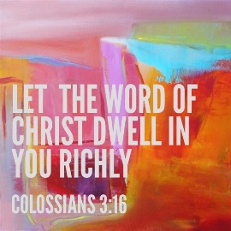
The Joy
- The only thing that will destroy the beast is the word of God
- What is your beast?
- What are you holding on too that needs to be let go of?
- It’s by the power of the Holy Spirit that we are able to destroy the beast
- There is beauty in holiness through the word of God
- Every thought, every action has to go back to reading God’s word
- We have treasure that is within, but you have to be willing to tame that fire starter the tongue
- You can tame the tongue so it can give way to the Holy Spirit manifesting itself through you.

